You can alter the text of this document as needed without permission of the author (Center for the Promotion of Excellence in Higher Education, Kyoto University) and use it to ensure that every student is informed of its contents. If you intend to distribute this very document as a template, clearly indicate the source (Center for the Promotion of Excellence in Higher Education, Kyoto University) and the date cited. Please let us know of your use of this document at: TeachingOnline@highedu.kyoto-u.ac.jp
April 17, 2020

mm dd, 2020
To Students

Associate Professor Xxxxx Yyyyy
Instructor of Xxxxx Course, Graduate School of Education
(xxx.yyy.zzz@kyoto-u.ac.jp)

Due to the spread of COVID-19, it has been decided to introduce nontraditional course formats for this academic year. According to the panel of experts, the risk of coronavirus infection increases in certain environments. Spread occurs in places that meet three specific conditions simultaneously, namely, (1) a poorly ventilated closed space, (2) close gathering of many people, and (3) conversations or vocalization in close distance. Unfortunately, the ordinary classroom is a space that is likely to simultaneously fulfill these three conditions.
Accordingly, in the first semester, this course will be entirely delivered online.
Course delivery methods and how to join class sessions are described below. Read through the following before you participate in the session.

■ Overall Course Description
This course is delivered using Zoom (a web conferencing system). All instructors also use Zoom to participate in class sessions. No changes have been made to the syllabus regarding the goals to be achieved, course plan, content, performance assessment method and perspective of the course.

■ Using Zoom: First Time Users
• To use Zoom for the first time in class, you need to download and install the application in advance (when you access “Meeting” in Zoom via PandA for the first time, the application is automatically downloaded and installed).
Reference: To attend class via Zoom (Information for Students)
https://kyoto-u.github.io/online-edu/zoom-student
• During the class, it becomes necessary to enable the video feature at certain times, as described below. You can use virtual background etc.
• During the class, you may be asked to speak. Fix audio settings, as described on the following page.
Zoom Help Center
https://support.zoom.us/hc/en-us
If, for some reason, you must mute your audio (i.e., you are hardly able to use audio for participation), contact the instructor beforehand. The instructor will allow you to join the class via the chat tool or by other measures.

■ How to Join a Zoom Class Meeting
• Log into PandA and tap “Zoom (KU License)” to go to the Zoom screen.
• Tap the Join button to the right of “Meeting” on the date of your class.
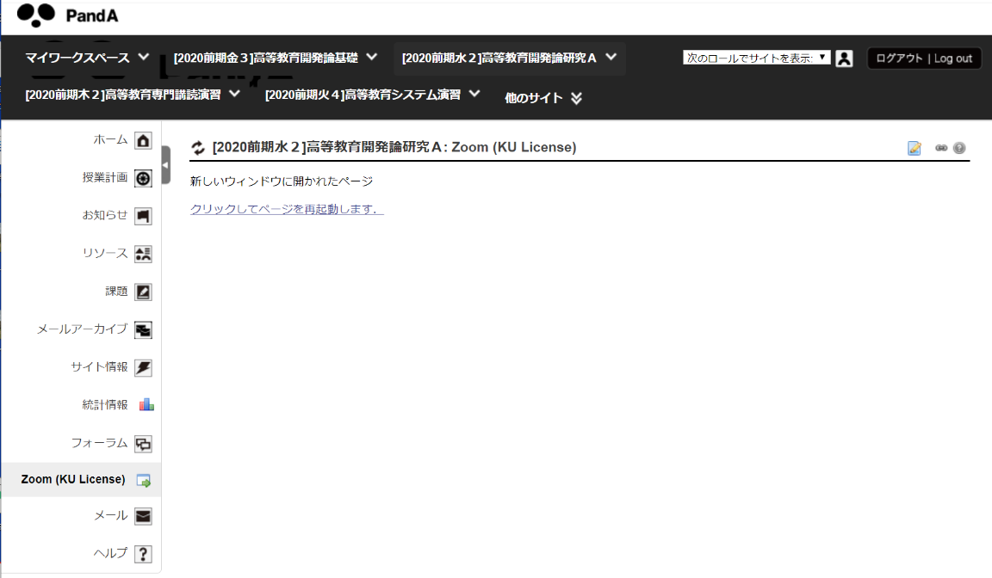
The Zoom screen opens after you click this button.

• If you encounter a problem, such as failure to enter the meeting, contact the TA via e-mail. The TA for this course is Xxxxx Yyyyy, D1 (xxx.yyy.zzz@st.kyoto-u.ac.jp).

The TA sets up a meeting room 20 minutes before the session starts. At that time, you will be able to enter the room. After entry, you can make small talk as long as you like until the session start time.

■ Points to Note When Handling the Zoom URL
To avoid unauthorized entries, enter the Zoom meeting room via PandA. Students must be made aware that they cannot post the Zoom URL on any SNS or other similar services.
(Currently, crimes that find Zoom URLs and disrupt meetings have been committed on a global scale.)

■ How the Class Proceeds
• In this course, scheduled presenters make research presentations.
For the schedule, see the Syllabus on PandA.
• A question and answer session is held during class.
• Students conduct after-class learning (notification of assignments, submission of assignments, comments on presentations, questions on presentations, etc.) using “Forums” on PandA.
• These procedures are detailed below.

By the Day before the Class Session
1. To make a research presentation, M2 and higher students, in particular, need to raise a topic in the following format “About the xth research presentation by Xxxxx” in “Forums” on PandA. There, they post research presentation manuscripts and provide background information and information on relevant papers for those new to the research, as students have varying degrees of prior knowledge.
(If you have no particular material to post, please raise a topic.)
2. Your presentation material should be uploaded to “Resources” on PandA in advance.

After Entering the Zoom Meeting Room
- The first five minutes or so after the session starts are used to inform the participants of miscellaneous matters. This time is also used to take roll call. Please enable the video feature during this time.
- When the presentation starts, all but the presenter should disable the video feature and mute the audio (turn off the microphone).
- To raise a question during the presentation, use the chat tool in Zoom.
- The presenter may answer the raised question(s) either in each instance or collectively at a natural break in the presentation. Alternatively, the presenter may encourage questions.

After-Class Hours
1. After the class session and by the end of the day, tap “Start a New Conversation” under the forum topic raised by the presenter and write a question or comment. This is compulsory for all M1 and M2 students (except for those who spoke satisfactorily during the class time). It is optional for postgraduates, postgraduates enrolled in a doctoral program, research staff, and teachers.
2. The presenter appropriately responds to comments and questions raised.

■ Zoom Settings and Functions Used during Class Sessions in This Course
• Enable the video feature in Zoom only at the start of the class session (for roll call).
• Use your real name for your username, as the participants will be called by their usernames. Postgraduates shall also indicate their years (Example: xxxx D3).
• While the presenter is making her/his presentation, disable the video feature and mute the audio (turn off the microphone).
• To raise a question during the presentation, use the chat tool in Zoom.
• When the presenter poses a question, enable the video feature and raise your hand to show your intention. Begin to speak after the presenter calls on you.

■ TA
• The TA for this course is Xxxxx, D1 (xxx.yyy.zzz@st.kyoto-u.ac.jp).
If there are any unclear points or concerns, contact the TA via e-mail.

